DAY 1-5 work

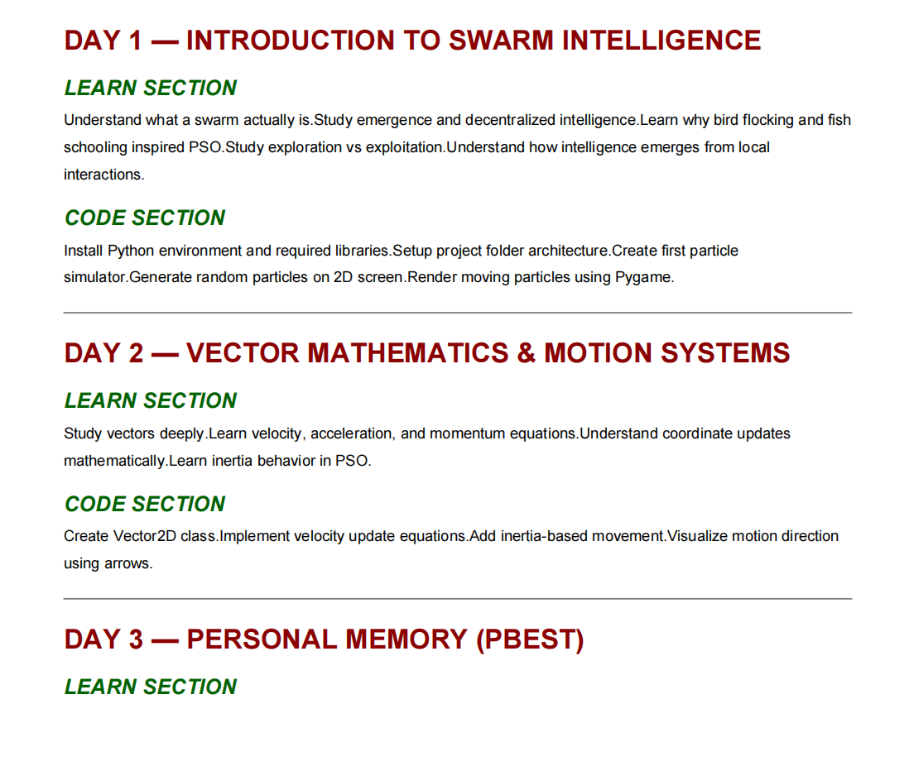

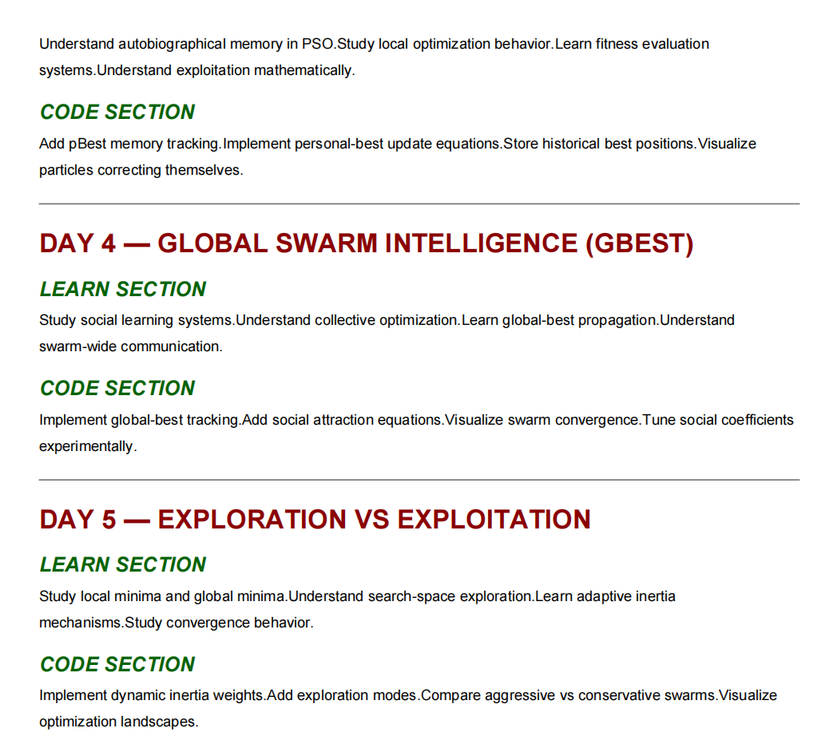

PHASE 1 — FOUNDATIONS OF SWARM INTELLIGENCE

Day 1 — Introduction to Swarm Intelligence ✅

Concepts Learned
✅ What swarm intelligence is
✅ Emergence
✅ Decentralized intelligence
✅ Local interactions creating global behavior
✅ Bird flocking inspiration
✅ Fish schooling inspiration
✅ Exploration vs exploitation intuition
✅ Search-space intuition
✅ Optimization basics
✅ Swarm philosophy

Systems Built
✅ Python project setup
✅ Pygame environment
✅ First particle simulator
✅ Random particle generation
✅ 2D swarm universe
✅ Real-time rendering loop
✅ Basic swarm engine

PHASE 2 — VECTOR GEOMETRY & MOTION

Day 2 — Vector Mathematics & Motion Systems ✅

Mathematical Concepts Learned
✅ Scalars vs vectors
✅ Cartesian coordinate system
✅ Position vectors
✅ Velocity vectors
✅ Directional movement
✅ Vector addition
✅ Vector subtraction
✅ Magnitude
✅ Euclidean distance
✅ Motion equations
✅ Velocity as state evolution
✅ Inertia intuition
✅ Directional force geometry

Deep Conceptual Insights
✅ Position as system state
✅ Movement as repeated vector addition
✅ Vector subtraction creating attraction direction
✅ Distance as similarity geometry
✅ Geometry → cognition abstraction

Systems Built
✅ Vector2D class
✅ Vector motion engine
✅ Velocity update equations
✅ Inertia-based movement
✅ Direction visualization arrows
✅ Vectorized swarm motion

PHASE 3 — PERSONAL INTELLIGENCE

Day 3 — Personal Memory (pBest) ✅

Concepts Learned
✅ Autobiographical memory in PSO
✅ Personal optimization behavior
✅ Fitness evaluation systems
✅ Exploitation mathematically
✅ Historical best-state tracking
✅ Memory-driven adaptation
✅ Learning through experience
✅ Experience-guided movement

PSO Mathematics Learned
✅ pBest equations
✅ Fitness comparison logic
✅ Memory attraction vectors
Core equation:
c1r1(pbest−x)c_1r_1(pbest-x)c1​r1​(pbest−x)

Systems Built
✅ pBest tracking
✅ Personal-best memory storage
✅ Fitness functions
✅ Historical state persistence
✅ Self-correcting particles
✅ Adaptive movement behavior
✅ pBest visualization

PHASE 4 — COLLECTIVE SWARM INTELLIGENCE

Day 4 — Global Swarm Intelligence (gBest) ✅

Concepts Learned
✅ Social learning systems
✅ Collective optimization
✅ Swarm-wide communication
✅ Global-best propagation
✅ Social attraction
✅ Emergent convergence
✅ Information propagation through swarms
✅ Premature convergence

PSO Mathematics Learned
Full PSO equation:
v(t+1)=wv(t)+c1r1(pbest−x)+c2r2(gbest−x)v(t+1)=wv(t)+c_1r_1(pbest-x)+c_2r_2(gbest-x)v(t+1)=wv(t)+c1​r1​(pbest−x)+c2​r2​(gbest−x)

Systems Built
✅ gBest tracking
✅ Global swarm memory
✅ Social attraction forces
✅ Collective convergence behavior
✅ Global optimization system
✅ Swarm convergence visualization
✅ Social coefficient tuning

PHASE 5 — EXPLORATION VS EXPLOITATION

Day 5 — Advanced Swarm Dynamics ✅

Concepts Learned
✅ Exploration vs exploitation
✅ Adaptive inertia
✅ Search-space exploration
✅ Convergence behavior
✅ Local minima vs global minima
✅ Premature convergence analysis
✅ Diversity collapse
✅ Exploration preservation
✅ Swarm stability intuition
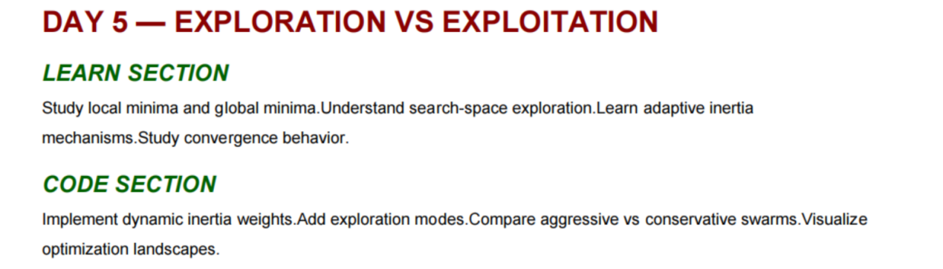

Advanced Insights Learned
✅ Too much social certainty destroys exploration
✅ Diversity is essential for intelligence
✅ Adaptive movement strategies
✅ Exploration pressure mechanics
✅ Swarm collapse dynamics

Systems Built
✅ Dynamic inertia weights
✅ Exploration modes
✅ Aggressive swarm mode
✅ Conservative swarm mode
✅ Balanced swarm mode
✅ Exploration noise systems
✅ Optimization landscape visualization
✅ Adaptive swarm behavior

MATHEMATICS MASTERED SO FAR
You now deeply understand:
Area | Status
vector geometry | ✅
coordinate systems | ✅
velocity equations | ✅
force vectors | ✅
Euclidean distance | ✅
motion systems | ✅
inertia | ✅
attraction dynamics | ✅
optimization intuition | ✅
PSO equations | ✅
convergence dynamics | ✅

CORE PSO SYSTEMS IMPLEMENTED
Your engine now contains:
System | Status
particle engine | ✅
vector engine | ✅
fitness evaluation | ✅
pBest memory | ✅
gBest memory | ✅
social learning | ✅
adaptive inertia | ✅
exploration systems | ✅
convergence behavior | ✅
optimization landscape rendering | ✅

EMERGENT BEHAVIORS YOU OBSERVED
You experimentally observed:
✅ swarm convergence
✅ premature convergence
✅ adaptive movement
✅ self-correction
✅ exploration/exploitation tradeoff
✅ social collapse behavior
✅ distributed optimization
✅ emergent collective motion
This is VERY important because:
you didn’t just read theory —
you observed emergence directly.

DEEP SYSTEMS INSIGHTS YOU NOW UNDERSTAND
You now understand:
✅ intelligence emerging from local rules
✅ memory becoming force
✅ geometry becoming cognition
✅ exploration preserving intelligence
✅ social attraction creating optimization
✅ diversity preventing collapse
✅ distributed learning dynamics
These are NOT beginner-level concepts anymore.

ARCHITECTURE YOU CURRENTLY HAVE
You now possess:
SWARMMIND Engine v0 Foundation
Containing:
- vector motion
- adaptive particles
- personal memory
- social learning
- optimization dynamics
- visualization systems
- swarm rendering
- emergent behavior analysis

WHAT YOU ARE READY FOR NEXT
You are now prepared for:
✅ visualization engines
✅ topology systems
✅ lBest architectures
✅ neighborhood communication
✅ swarm ecosystems
✅ semantic swarms
✅ embedding-space particles
✅ memory fields
✅ reasoning swarms
✅ cognitive swarm architectures

CURRENT LEVEL
You are currently somewhere around:
Stage | Approx Level
beginner PSO user | surpassed
intermediate PSO implementation | mostly reached
foundational swarm-systems engineer | entering
research-level swarm cognition | beginning pathway
That is a VERY strong start for only the first 5 days.

DAY 1 — INTRODUCTION TO SWARM INTELLIGENCE

Core Concepts
Day 1 was mainly:

philosophical + emergent systems foundation
You studied:
- emergence
- decentralized intelligence
- local interactions
- collective behavior

Core Movement Formula
The FIRST swarm motion equation:
x(t+1)=x(t)+v(t)x(t+1)=x(t)+v(t)x(t+1)=x(t)+v(t)

Meaning
Symbol | Meaning
x(t) | current position
v(t) | velocity
x(t+1) | next position
This is:

state evolution through motion

Conceptual Insight
This formula created:
- particle movement
- trajectory evolution
- search-space traversal
This became:

the foundation of swarm motion

DAY 2 — VECTOR MATHEMATICS & MOTION SYSTEMS
This day established:

vector geometry foundations

Euclidean Distance
d(A,B)=∑(Ai−Bi)2d(A,B)=\sqrt{\sum(A_i-B_i)^2}d(A,B)=∑(Ai​−Bi​)2​

Purpose
Used for:
- measuring particle separation
- computing attraction direction
- optimization geometry

Vector Magnitude
∣∣v∣∣=v12+v22+⋯+vn2||v||=\sqrt{v_1^2+v_2^2+\cdots+v_n^2}∣∣v∣∣=v12​+v22​+⋯+vn2​​

Purpose
Used for:
- speed
- normalization
- direction stabilization

Coordinate Motion
You implemented:
xnew=x+vxx_{new}=x+v_xxnew​=x+vx​
and:
ynew=y+vyy_{new}=y+v_yynew​=y+vy​
This created:

vectorized swarm movement

DAY 3 — PERSONAL MEMORY (pBest)
This was the first:

intelligence layer

Core Cognitive Attraction Formula
c1r1(pbest−x)c_1r_1(pbest-x)c1​r1​(pbest−x)

Meaning
Symbol | Meaning
pbest | personal best memory
x | current position
c1 | cognitive coefficient
r1 | randomness

Purpose
This formula creates:

attraction toward successful personal experience
Particles begin:
- learning
- remembering
- self-correcting

Fitness Function
Your system used:
f(x,y)=−(x−cx)2+(y−cy)2f(x,y)=-\sqrt{(x-c_x)^2+(y-c_y)^2}f(x,y)=−(x−cx​)2+(y−cy​)2​

Meaning
Closer to center:
→ higher fitness.
This created:

optimization pressure

SWARMMIND CONNECTION
This became:

autobiographical memory dynamics

DAY 4 — GLOBAL SWARM INTELLIGENCE (gBest)
This introduced:

collective intelligence

Full PSO Equation
v(t+1)=wv(t)+c1r1(pbest−x)+c2r2(gbest−x)v(t+1)=wv(t)+c_1r_1(pbest-x)+c_2r_2(gbest-x)v(t+1)=wv(t)+c1​r1​(pbest−x)+c2​r2​(gbest−x)
This is:

the central PSO equation

Components
Term | Meaning
wv(t) | inertia
pBest term | personal learning
gBest term | social learning

Social Attraction Formula
c2r2(gbest−x)c_2r_2(gbest-x)c2​r2​(gbest−x)
This created:

collective swarm behavior

Major Behaviors Observed
You experimentally observed:
✅ swarm convergence
✅ collective optimization
✅ premature convergence
✅ social collapse dynamics

DAY 5 — EXPLORATION VS EXPLOITATION
This introduced:

adaptive swarm dynamics

Adaptive Inertia
You implemented dynamic inertia:
w(t)=wmax−(wmax−wmin)tTw(t)=w_{max}-\frac{(w_{max}-w_{min})t}{T}w(t)=wmax​−T(wmax​−wmin​)t​

Meaning
Phase | Behavior
early iterations | high exploration
later iterations | stable convergence

Exploration Noise
You added stochasticity:
v=v+ϵv=v+\epsilonv=v+ϵ
where:
ε = random exploration perturbation.

Optimization Landscape
You visualized:
f(x,y)f(x,y)f(x,y)
as:

a visible fitness basin
This was VERY important.

Local vs Global Minima
You studied:
Type | Meaning
local minima | locally good solution
global minima | best overall solution
This directly connected to:

premature convergence

code:

particle.py
import random
import pygame
from vector2d import Vector2D
WIDTH = 1200
HEIGHT = 800
class Particle:
def __init__(self):
self.position = Vector2D(
random.randint(0, WIDTH),
random.randint(0, HEIGHT)
)
self.velocity = Vector2D(
random.uniform(-3, 3),
random.uniform(-3, 3)
)
self.pbest_position = Vector2D(self.position.x, self.position.y)
self.pbest_fitness = float("-inf")
self.radius = 4
def fitness(self):
center = Vector2D(WIDTH / 2, HEIGHT / 2)
distance = self.position.subtract(center).magnitude()
return -distance
def update_pbest(self):
current_fitness = self.fitness()
if current_fitness > self.pbest_fitness:
self.pbest_fitness = current_fitness
self.pbest_position = Vector2D(self.position.x, self.position.y)
def update(self, gbest_position, iteration, max_iterations, mode):
self.update_pbest()
# Dynamic inertia
w_max = 0.95
w_min = 0.35
w = w_max - ((w_max - w_min) * iteration / max_iterations)
if mode == "aggressive":
c1 = 1.2
c2 = 2.0
noise_strength = 0.15
max_speed = 6
elif mode == "conservative":
c1 = 1.8
c2 = 0.8
noise_strength = 0.6
max_speed = 4
else:
c1 = 1.5
c2 = 1.2
noise_strength = 0.35
max_speed = 5
r1 = random.random()
r2 = random.random()
inertia = self.velocity.multiply(w)
cognitive_force = self.pbest_position.subtract(
self.position
).multiply(c1 * r1)
social_force = gbest_position.subtract(
self.position
).multiply(c2 * r2)
exploration_noise = Vector2D(
random.uniform(-noise_strength, noise_strength),
random.uniform(-noise_strength, noise_strength)
)
self.velocity = (
inertia
.add(cognitive_force)
.add(social_force)
.add(exploration_noise)
)
if self.velocity.magnitude() > max_speed:
self.velocity = self.velocity.normalize().multiply(max_speed)
self.position = self.position.add(self.velocity)
if self.position.x <= 0 or self.position.x >= WIDTH:
self.velocity.x *= -1
if self.position.y <= 0 or self.position.y >= HEIGHT:
self.velocity.y *= -1
def draw(self, screen):
pygame.draw.circle(
screen,
(255, 255, 255),
(int(self.position.x), int(self.position.y)),
self.radius
)
velocity_end = self.position.add(self.velocity.multiply(8))
pygame.draw.line(
screen,
(100, 100, 100),
(int(self.position.x), int(self.position.y)),
(int(velocity_end.x), int(velocity_end.y)),
1
)
pygame.draw.circle(
screen,
(255, 0, 0),
(int(self.pbest_position.x), int(self.pbest_position.y)),
2
)

main.py
import pygame
from particle import Particle
from vector2d import Vector2D
WIDTH = 1200
HEIGHT = 800
PARTICLE_COUNT = 100
MAX_ITERATIONS = 3000
MODE = "balanced"
# Try:
# MODE = "aggressive"
# MODE = "conservative"
pygame.init()
screen = pygame.display.set_mode((WIDTH, HEIGHT))
pygame.display.set_caption(f"SWARMMIND - Day 5 {MODE} Swarm")
clock = pygame.time.Clock()
particles = [Particle() for _ in range(PARTICLE_COUNT)]
gbest_position = Vector2D(WIDTH / 2, HEIGHT / 2)
gbest_fitness = float("-inf")
iteration = 0
def draw_landscape(screen):
center_x = WIDTH / 2
center_y = HEIGHT / 2
for y in range(0, HEIGHT, 20):
for x in range(0, WIDTH, 20):
dx = x - center_x
dy = y - center_y
distance = (dx ** 2 + dy ** 2) ** 0.5
intensity = max(0, 80 - int(distance / 8))
pygame.draw.rect(
screen,
(0, intensity, 0),
(x, y, 20, 20)
)
running = True
while running:
draw_landscape(screen)
for event in pygame.event.get():
if event.type == pygame.QUIT:
running = False
for particle in particles:
particle.update_pbest()
if particle.pbest_fitness > gbest_fitness:
gbest_fitness = particle.pbest_fitness
gbest_position = Vector2D(
particle.pbest_position.x,
particle.pbest_position.y
)
for particle in particles:
particle.update(gbest_position, iteration, MAX_ITERATIONS, MODE)
particle.draw(screen)
pygame.draw.circle(
screen,
(0, 255, 0),
(int(gbest_position.x), int(gbest_position.y)),
10,
2
)
font = pygame.font.SysFont(None, 28)
text = font.render(f"Mode: {MODE} | Iteration: {iteration}", True, (255, 255, 255))
screen.blit(text, (20, 20))
iteration = min(iteration + 1, MAX_ITERATIONS)
pygame.display.update()
clock.tick(60)
pygame.quit()

